PRESS-RELEASE

THE REAL ABBA tribute
feat. Ms. Dany REITER & Ms. Karin JANDA
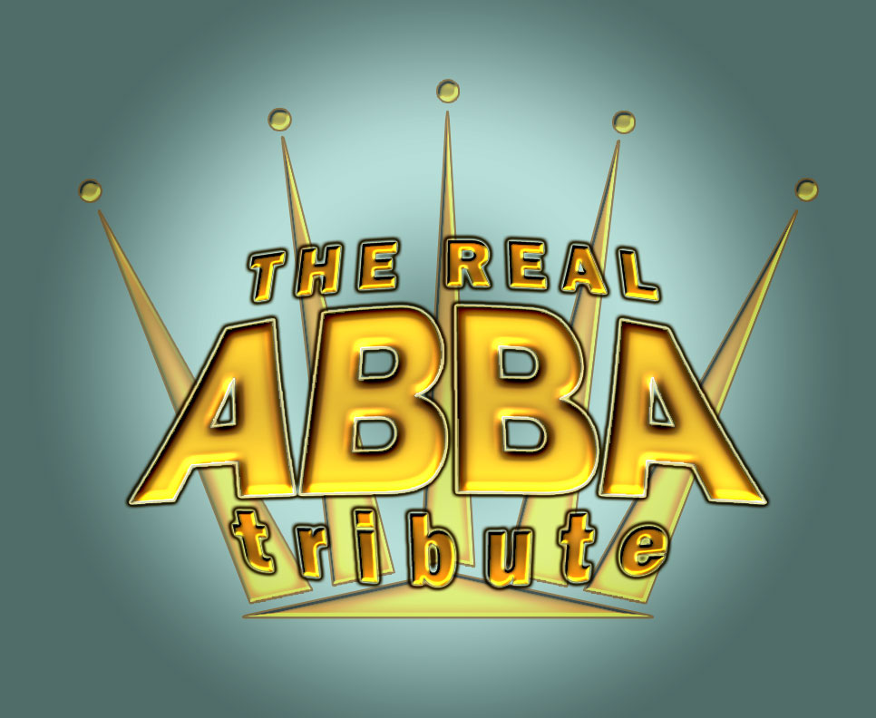

“Mamma Mia – what an exciting ABBA Cover-Show!”

THE REAL ABBA tribute - the internationally renowned act from the musical metropolis Vienna is thrilling the audiences with the world-famous hits of ABBA. “Mamma Mia – what a show(band)!”
Particularly the two female protagonists Dany REITER (as “Anni-Frid” or “Frida”) and Karin JANDA (as “Agnetha”), with their outstanding voices and an intricate, electrifying and unparalleled stage show – have consistently given THE REAL ABBA tribute a unique
“Spirit of ABBA”.
Completed by Hannes DROBETZ (as “Benny”) and Andy FREUND (as “Björn”), the dynamic and energetic lineup mesmerizes audiences with emotion, wit and charm.
THE REAL ABBA tribute is a world-class musical and stage experience – from the first notes to the last encore. This dedication not only has earned enthusiastic applause at each performance, but is also held in high regard by recognized experts in Austria and abroad.
Having performed together with the group, for example, bandleader & RTL All-Star Band mastermind Martin ERNST still has the highest praise for Dany, Karin, Andy and Hannes, calling them “the best ABBA covers we have had the pleasure of accompanying in our 15-year history – simply top-class.”
Audiences entertained by the band have included famous guests such as Chris de Burgh and his daughter, Miss World Rosanna Davison; “Mr. Ballerman” Jürgen Drews; Hugo Egon Balder; Ralf Möller; the Klitschko brothers; Jimmy Somerville; “Kaiser” Franz Beckenbauer; Magna International CEO Siegfried Wolf; Mr. Life-Ball Gerry Keszler; skiing star Stephan Eberharter and many more. Dany & Karin’s successful career together with her “husbands” has included celebrated performances at the Wörthersee Night Of The Stars, Circus Krone in Munich, Friedrichstadt Palace in Berlin and the Liederhalle in Stuttgart, as well as concerts on the Azores-Island, in Cairo/Egypt, in Warshaw/Poland, in Moskaw/Russia, in Sorrento/Italy and on the island of Madeira.
In their current “The 40th Anniversary – Show 2013/14”, THE REAL ABBA tribute presents a successful combination of modern entertainment and authentic performance. The new sound design conveys a musical experience to the stage, as well as in particular to the audience, that presumably even the original Swedish band would find impressive.
For months, the band worked together with internationally renowned producers on a mix of true-to-the-original musical arrangements, modern sound elements and catchy, detailed choral elements. Another highlight of the show are the unmistakable, glamorous costumes that were ABBA’s trademark. Additional stage accessories and decorative elements perfectly round out this unique show.
THE REAL ABBA tribute delivers a perfect stage show – be it on festival stages, at elegant galas or at their own concert-evenings.
THE REAL ABBA tribute celebrates an unforgettable journey in time through 10 years of music history. The band plays all the legendary ABBA hits with plenty of party atmosphere for all generations – that’s right, our kids and teenagers are currently becoming “ABBA Singstars”… from the occasional rocking rhythm to selected ballads presented in unique unplugged versions guaranteed to give listeners goosebumps, such as:
Angel eyes, Chiquitita, Dancing Queen, Does your mother know, Fernando, Gimme Gimme Gimme, Honey Honey, I have a dream, Knowing me knowing you, Mamma Mia, Money Money Money, One of Us, Ring Ring, S.O.S., Summer Night City, Super Trouper, Take a chance on me, Thank you for the music, The winner takes it all, Under Attack, Voulez Vous, Waterloo, and many more..

THE REAL ABBA tribute are:
Karin JANDA – as „Agnetha“
Hannes DROBETZ – as “Benny”
Andy FREUND – as „Björn“
Dany REITER – as „Anni-Frid“ („Frida“)

For particular occasions respectively special events and concerts THE REAL ABBA tribute presents a terrific Live-Band assembled by the “All-Star-Musicians” of Austria´s Rock/Pop- and Musical scene of international rank. Under the lead of musical director Gerald GRATZER the show turns to an extraordinary live-event impressively close to original ABBA.

The band of THE REAL ABBA tribute are:
Gerald GRATZER - drums / musical director
Stephan FÖRST - bass
Harry PELLER - guitar
Martin PAYR - keyboard.

Demonstrative Songlist
(in alphabetical order – changes are possible)
ANGEL EYES
CHIQUITITA
DANCING QUEEN
DOES YOUR MOTHER KNOW
EAGLE
FERNANDO
GIMME GIMME GIMME!
HEAD OVER HEELS
HONEY HONEY
I DO, I DO, I DO, I DO, I DO
I HAVE A DREAM
IN THE NAME OF THE GAME
KNOWING ME, KNOWING YOU
LAY ALL YOUR LOVE ON ME
MAMMA MIA

MONEY, MONEY, MONEY
ON AND ON AND ON
ONE OF US
OUR LAST SUMMER
RING RING
ROCK ME
S.O.S.
SUMMER NIGHT CITY
SUPER TROUPER
TAKE A CHANCE ON ME
THANK YOU FOR THE MUSIC
THE NAME OF THE GAME
THE WAY OLD FRIENDS DO
THE WINNER TAKES IT ALL
UNDER ATTACK
VOULEZ-VOUS
WATERLOO
(some songs will be performed as medleys)

Maximum length of the program: 120 minutes net in 1 or 2 sets (break rd. 20 min.) – details can be arranged

© Copyright by THE REAL ABBA tribute
represented by Ms. Dany REITER & Ms. Karin JANDA
www.THE-REAL-ABBA.com

Contact:
Mr. Christian Piereder
International Promotion, Management & Booking
Mobil: +43 - (0)676 – 355 66 17
Tel/Fax: +43 – (0)1 – 945 80 35
Mail to: office@the-real-abba.com
Mail to: c.piereder@showroOom.at

for
THE REAL ABBA tribute GesnbR
Ms. Dany REITER and Ms. Karin JANDA
Wiedner Hauptstrasse 66 / 13
1040 Wien/Vienna – Austria (Europe)
(UID: ATU 648 605 37)

